Log in to AWS Management Console <https://aws.amazon.com/console/>

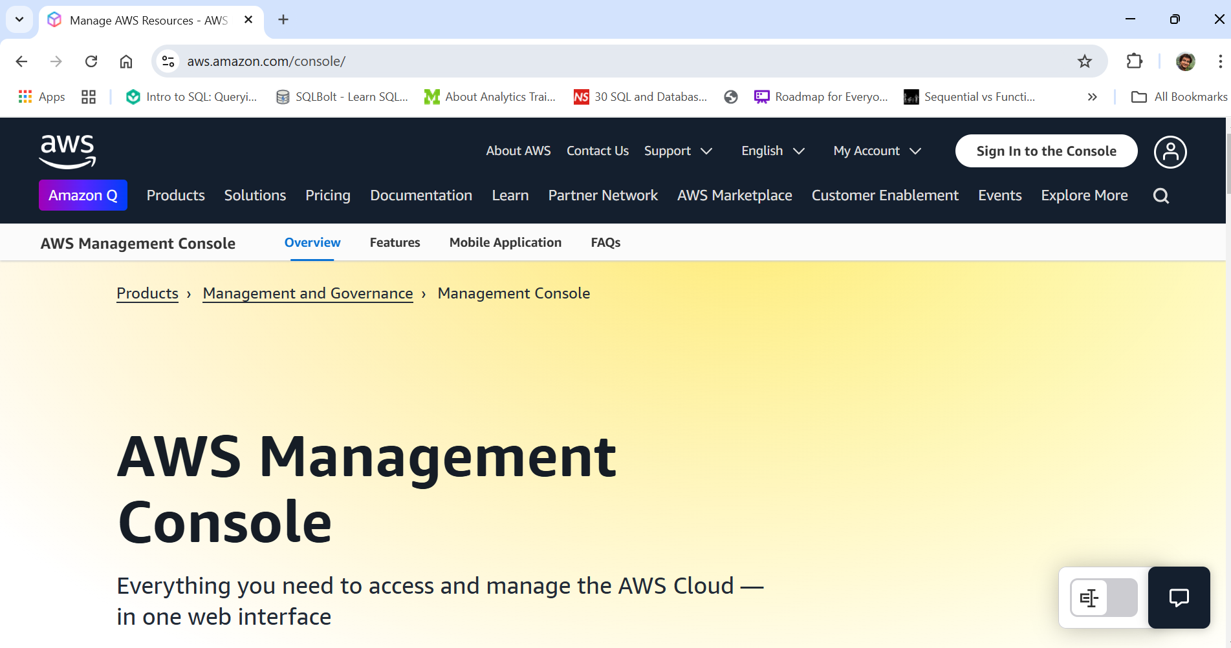

Navigate to S3 under “Storage”

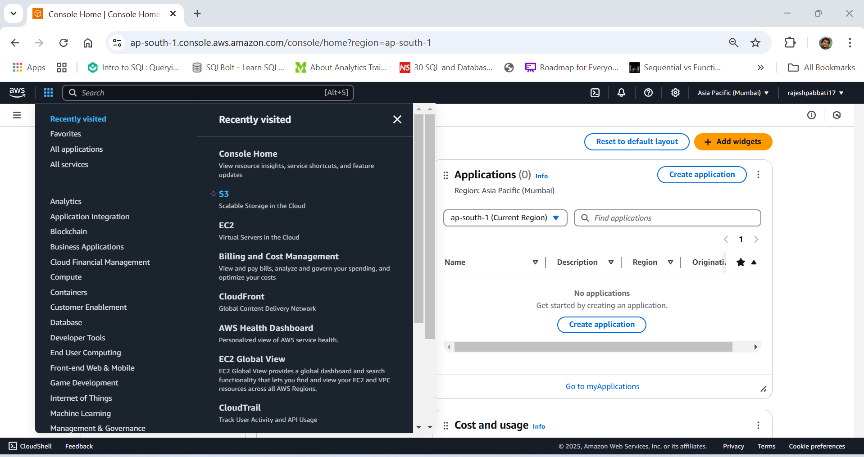

Click on Create Bucket

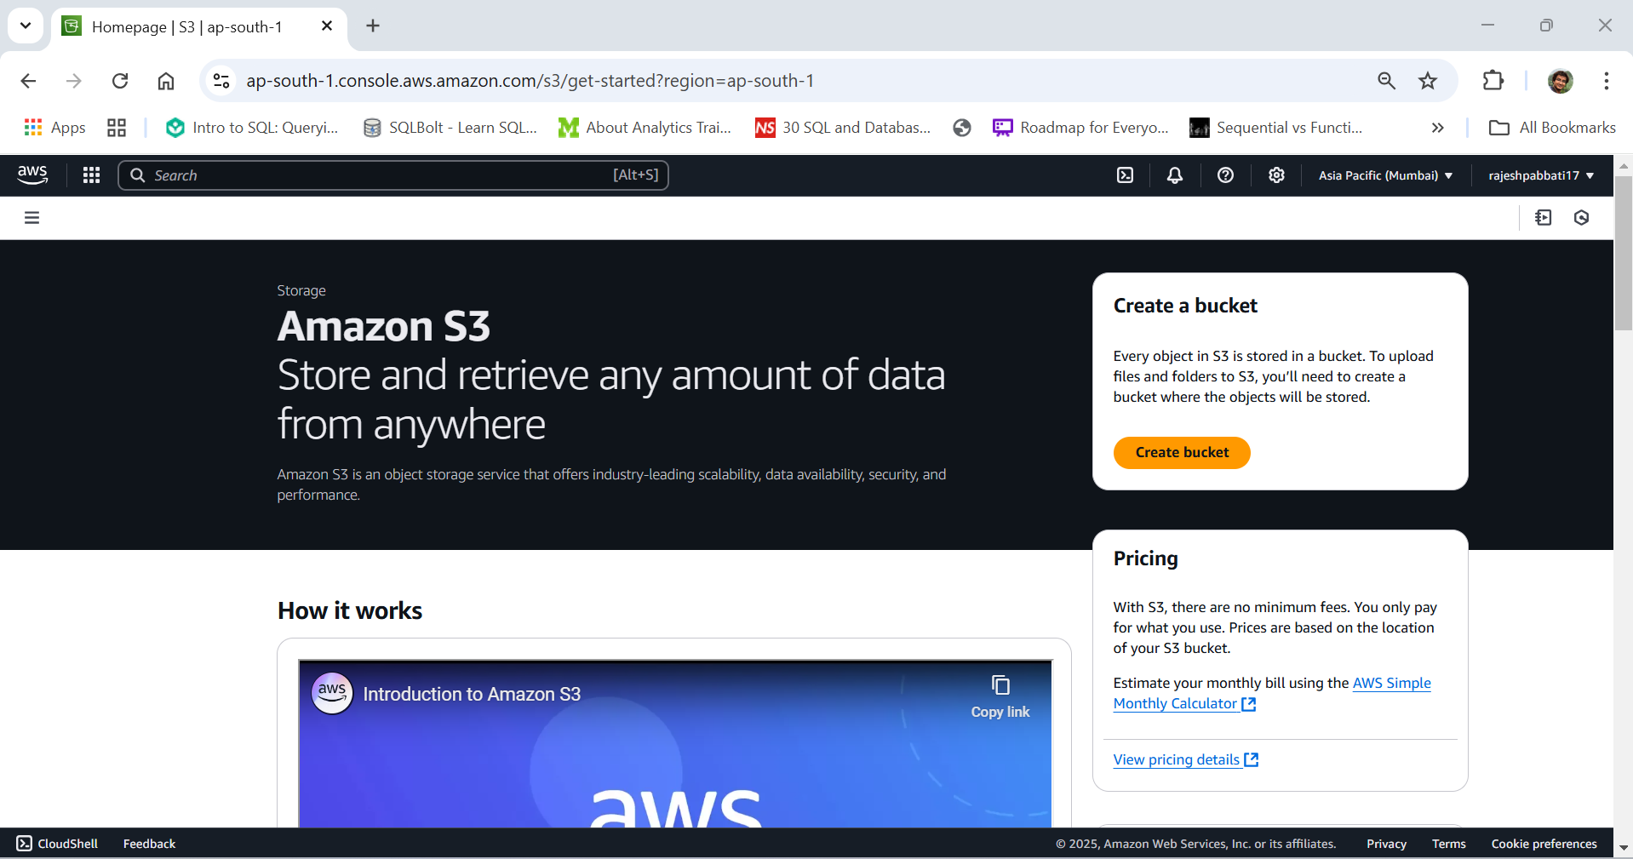

Enter unique bucket name

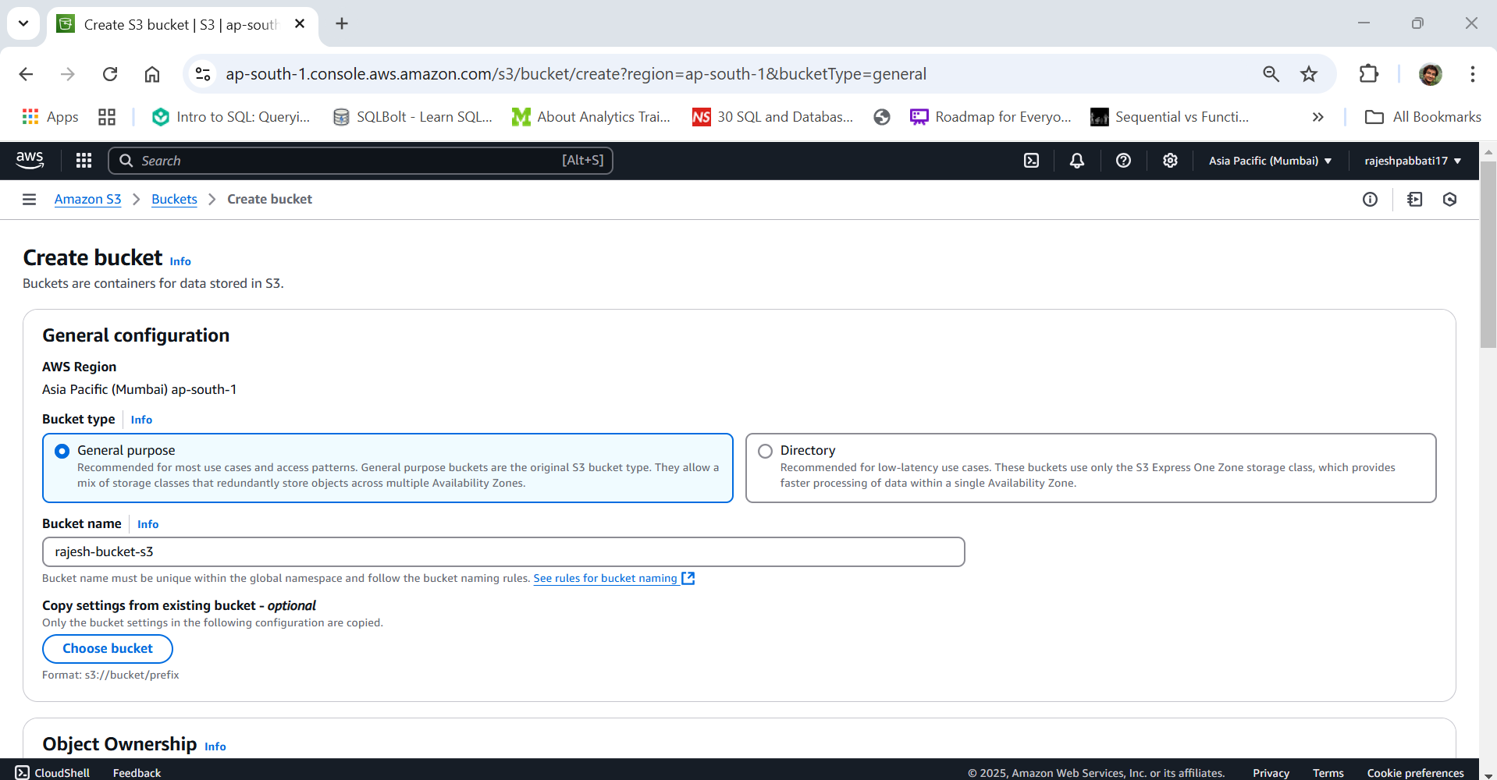

Leave other settings as default and click Create bucket

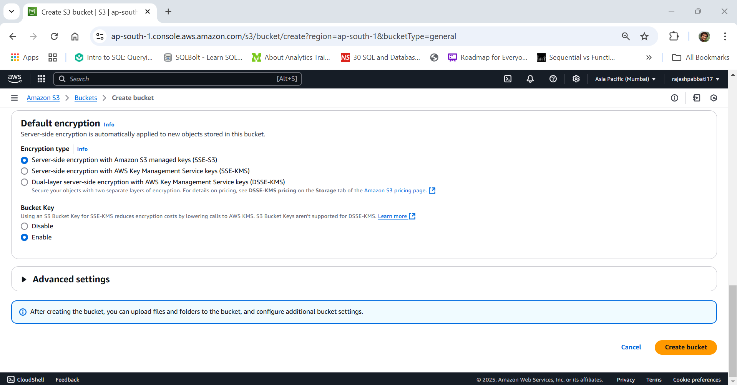

1. Upload an object to bucket

Click on bucket name

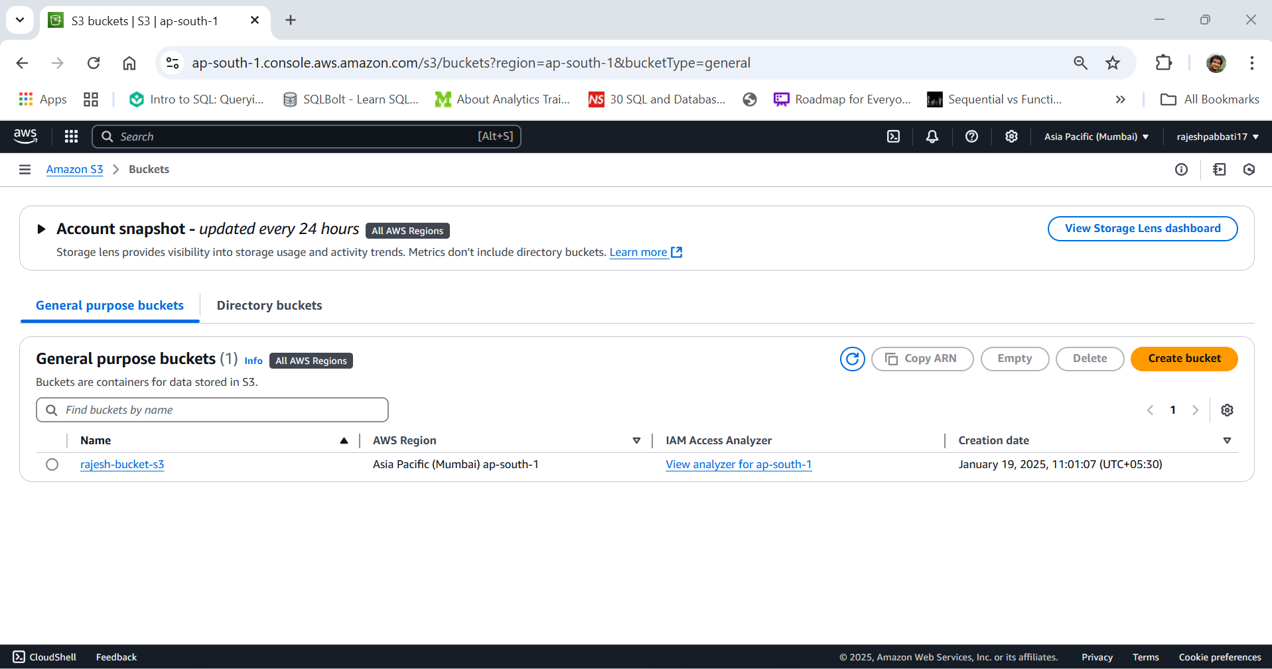

Click on upload and add files and upload

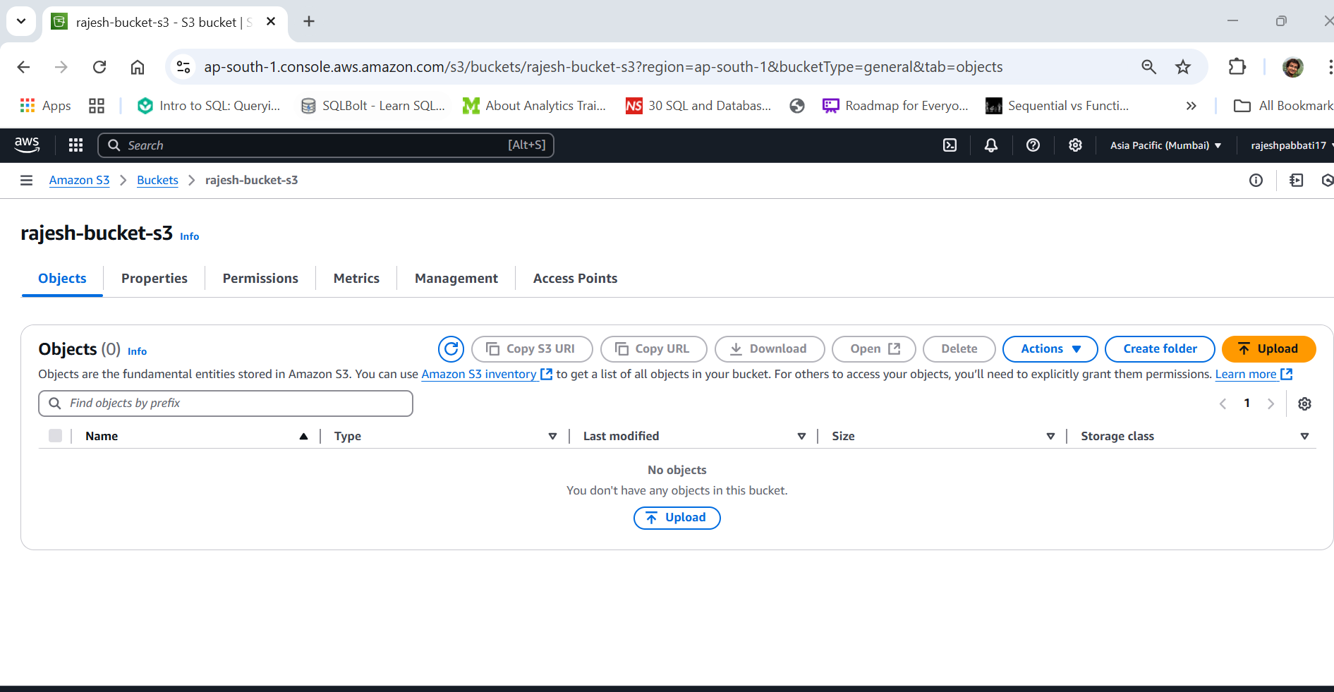

File uploaded

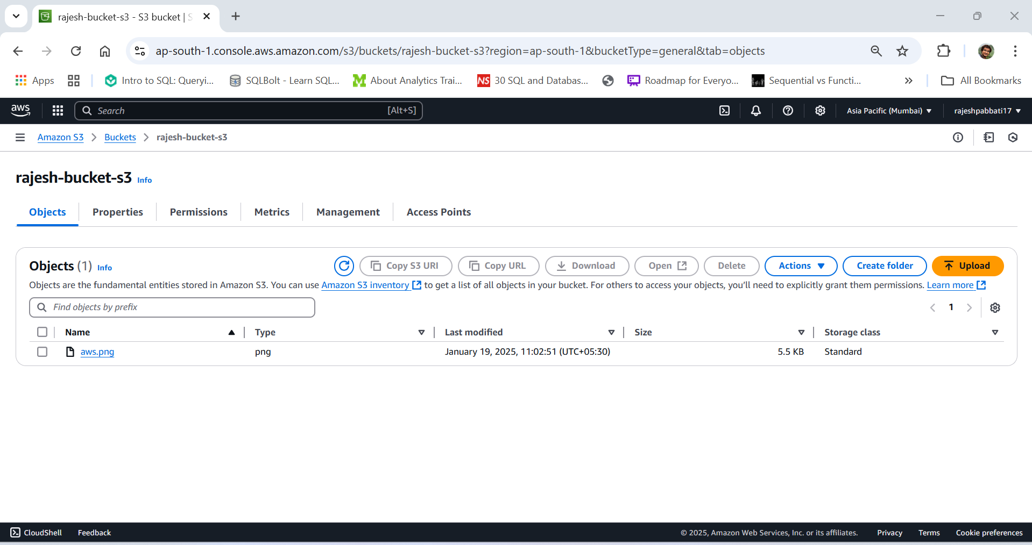

1. Download an object

Select file and click on download

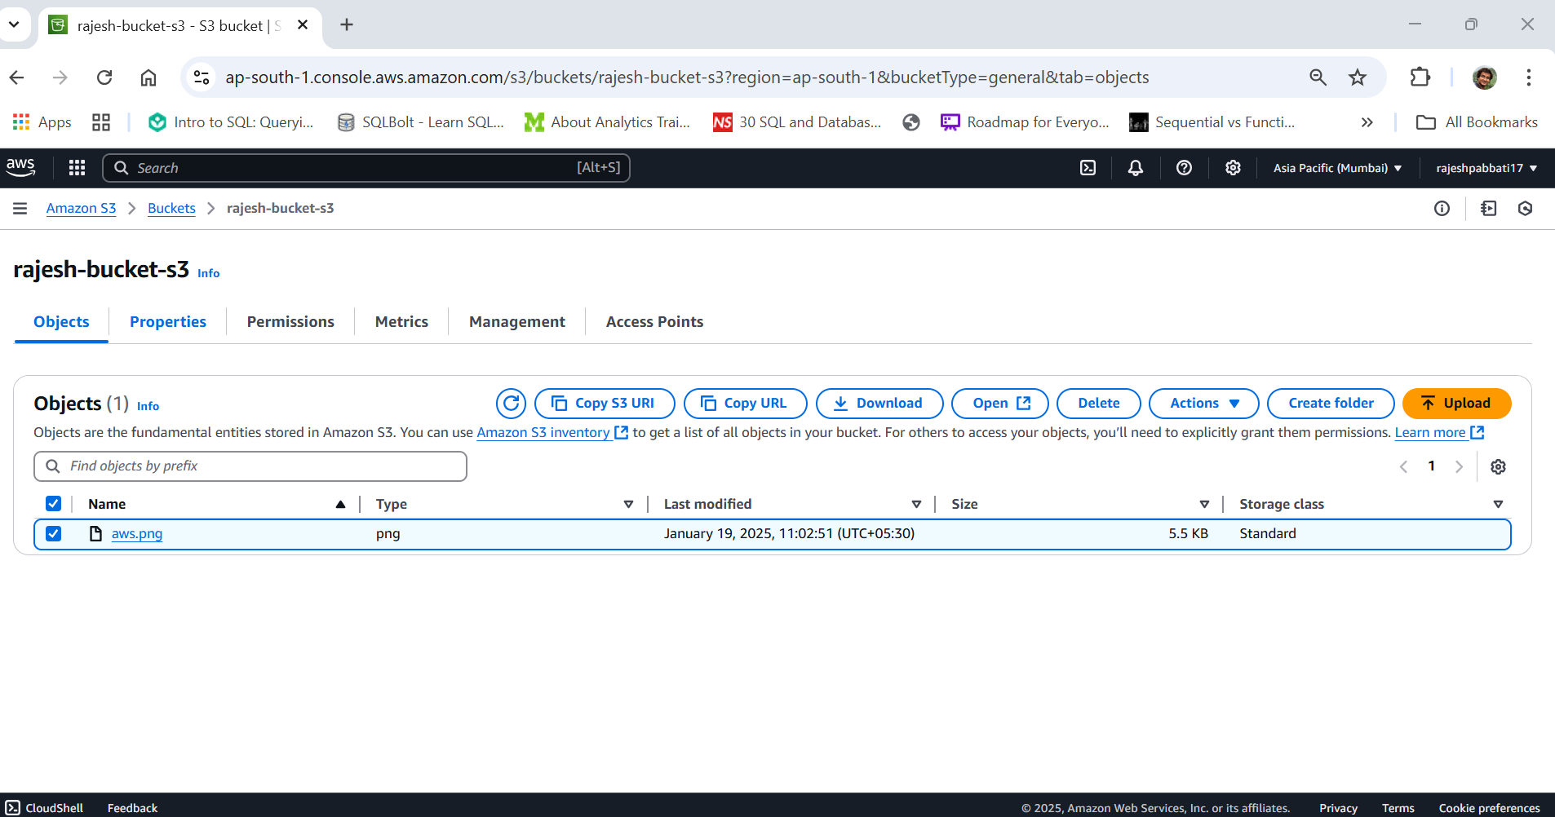

1. Copy object to a folder

Click on create folder

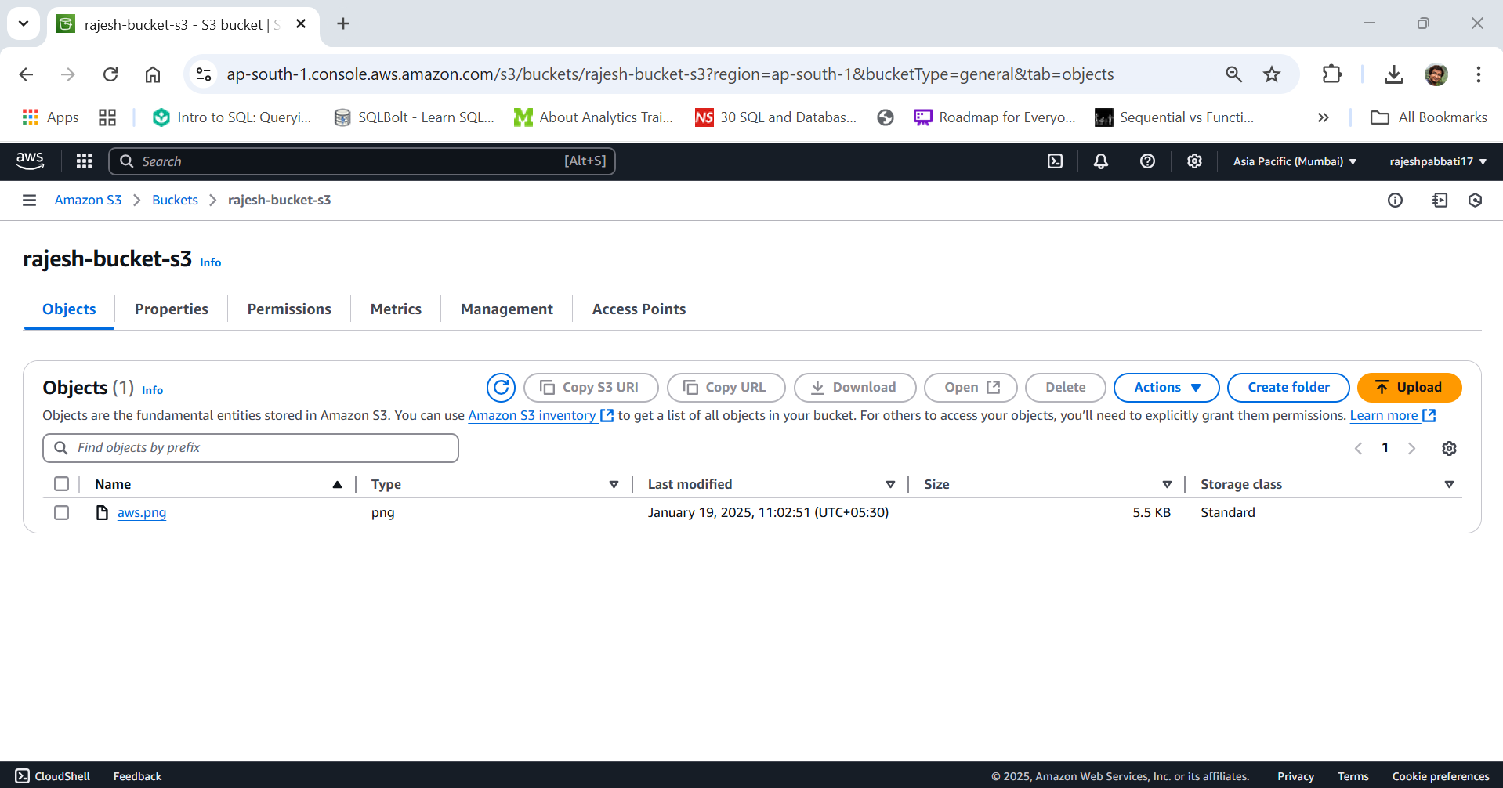

Enter folder name and click on Create folder

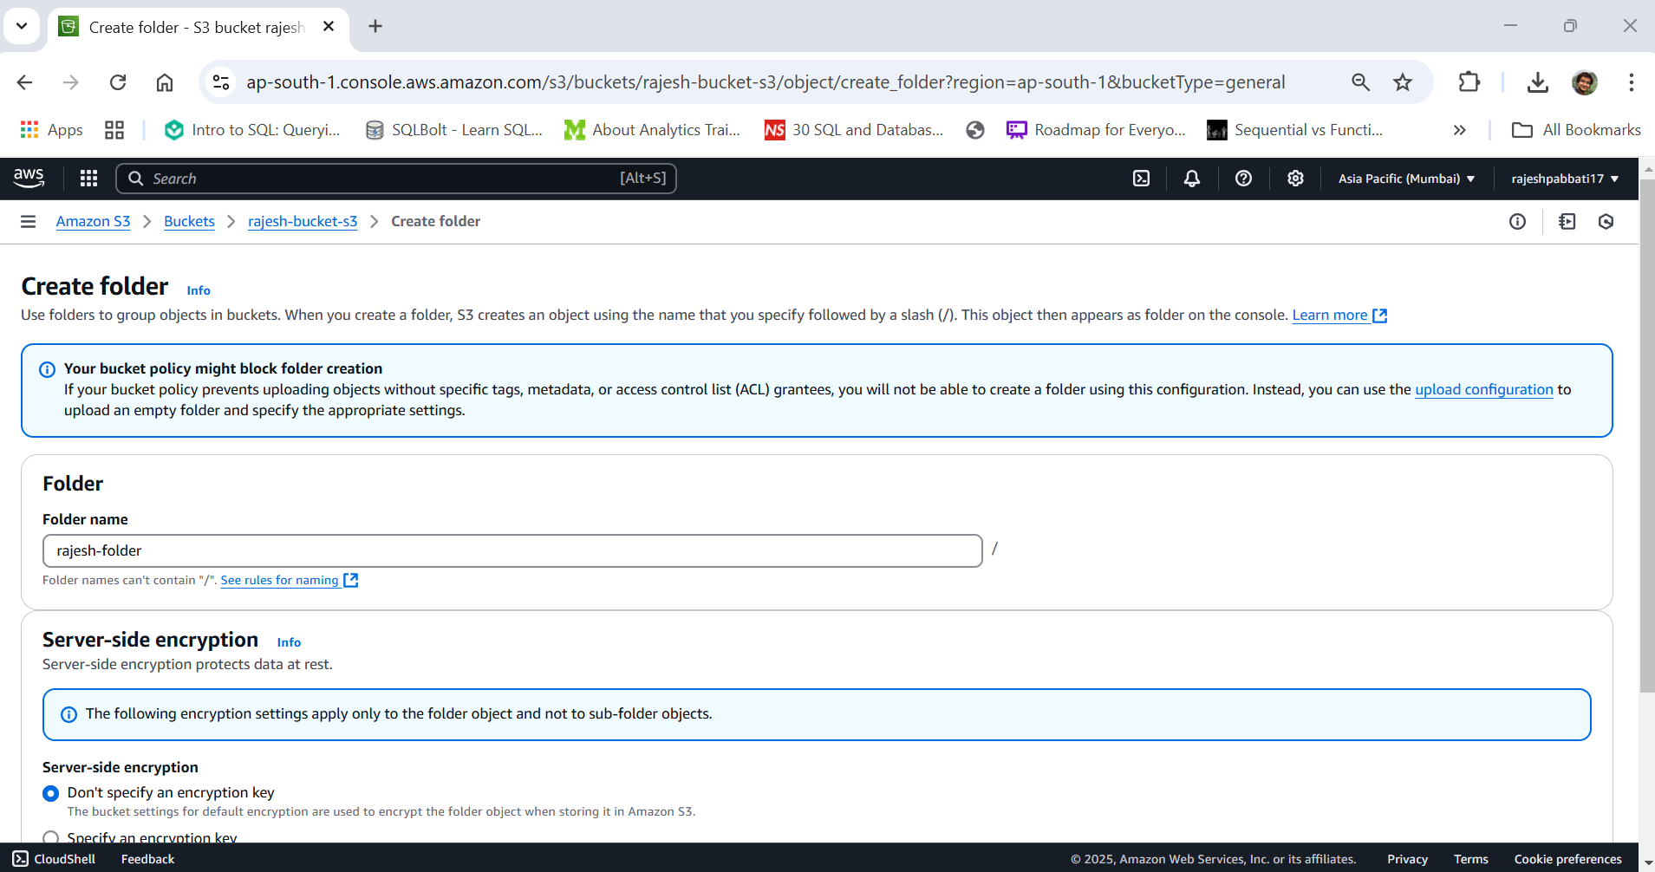

Folder is created

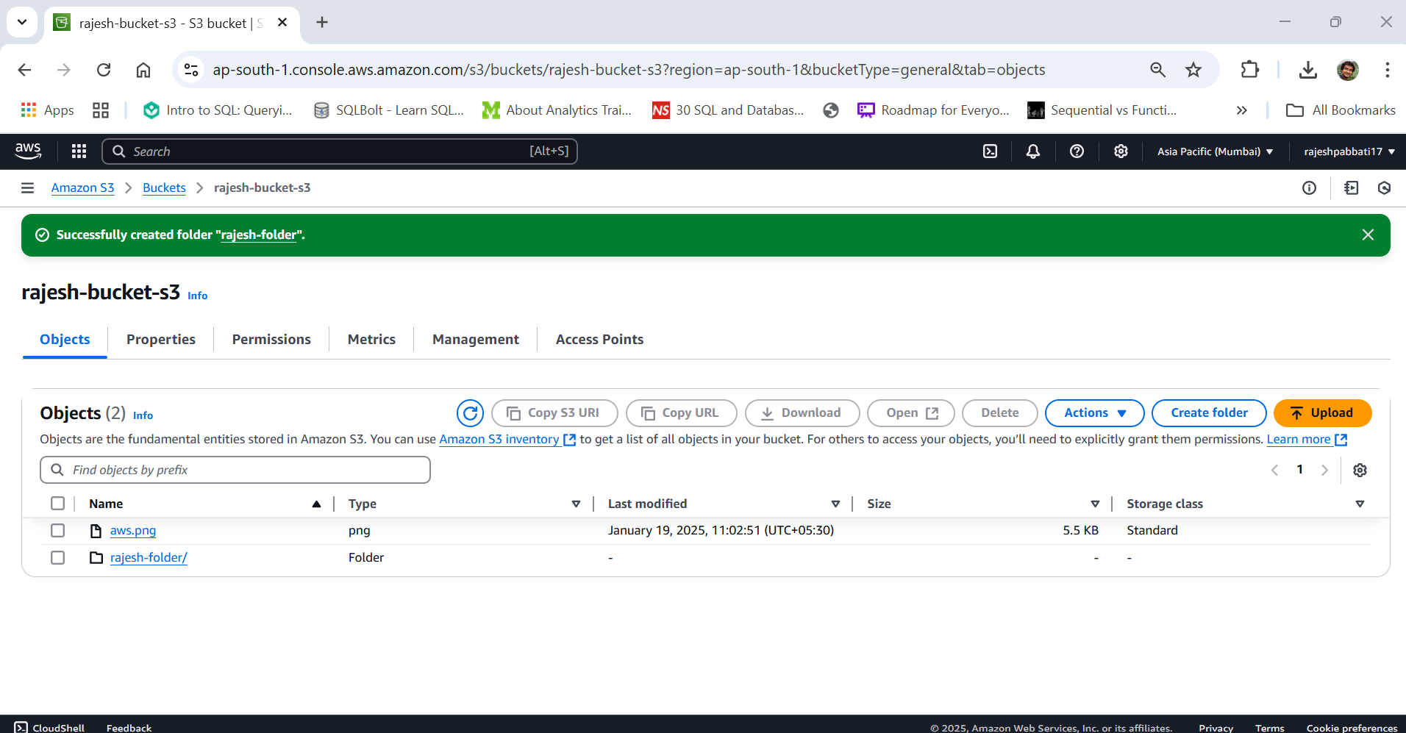

Check the box next to the file, then click Actions -> Copy

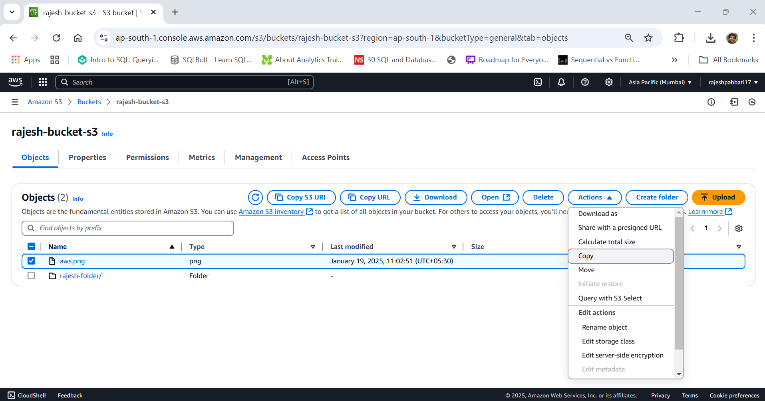

Choose destination bucket

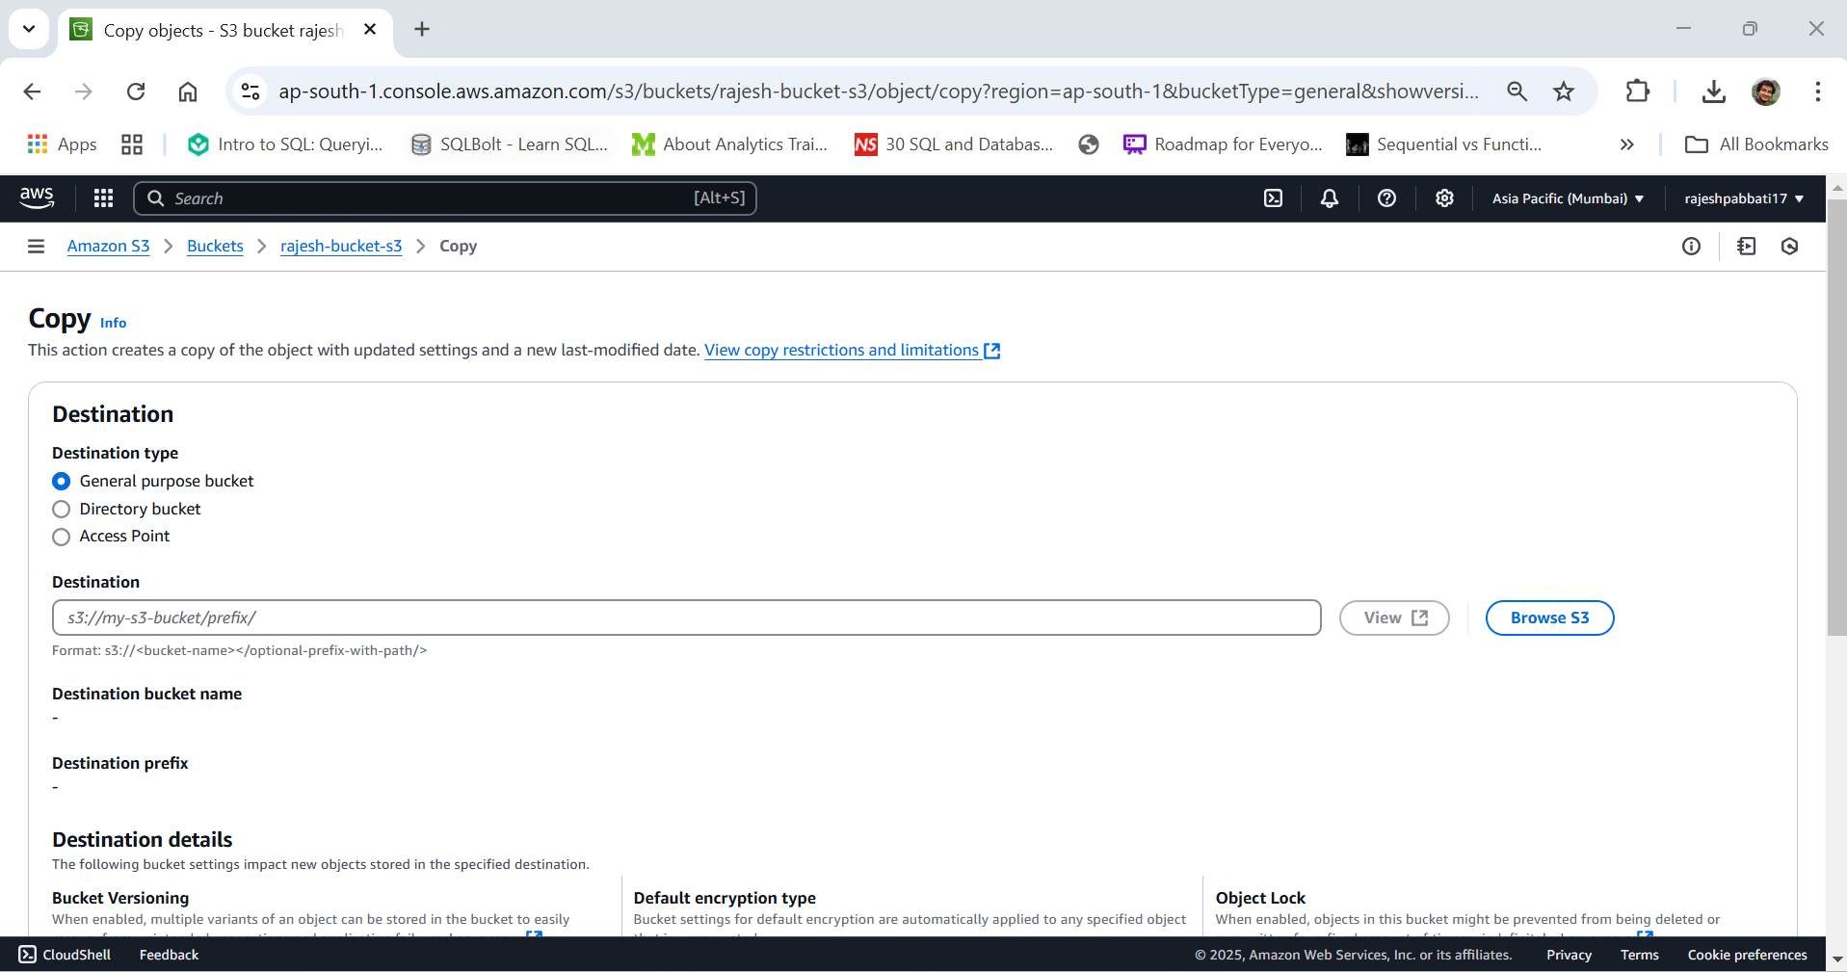

Choose destination folder and click on copy

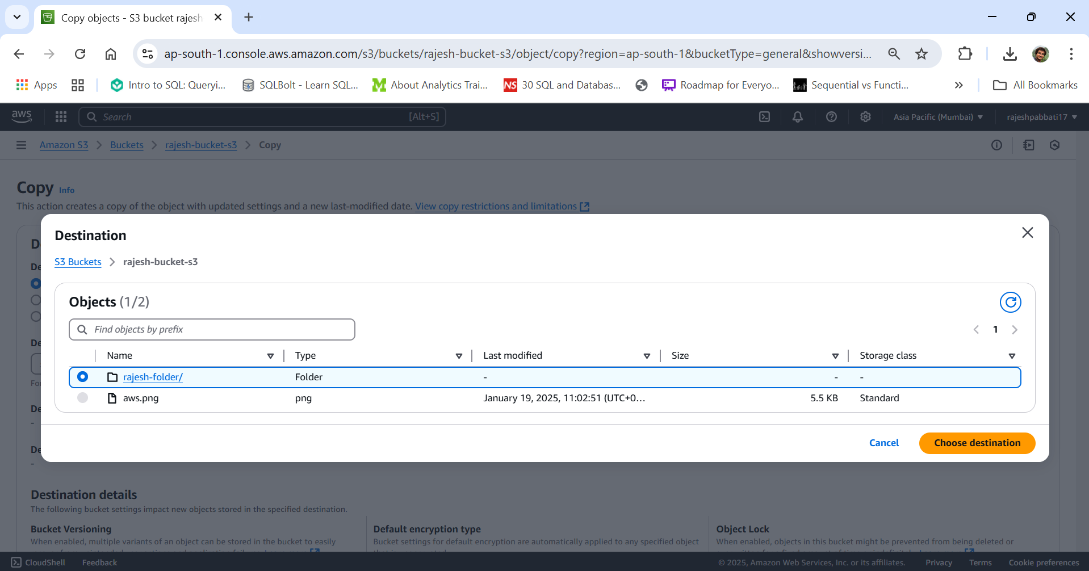

File is copied from S3 bucket to newly created folder

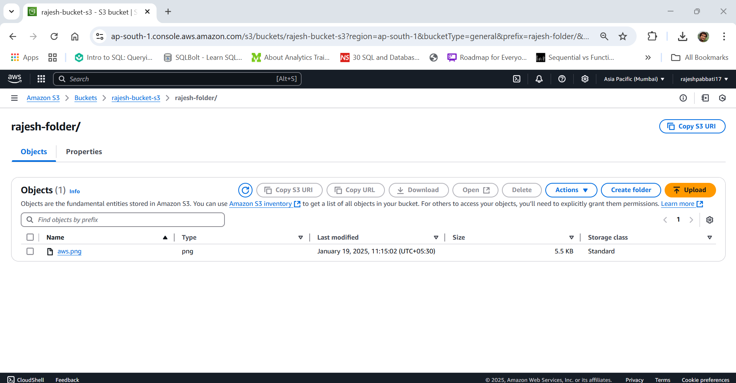

1. Delete objects and bucket

Delete all objects in bucket by selecting all files and click on delete

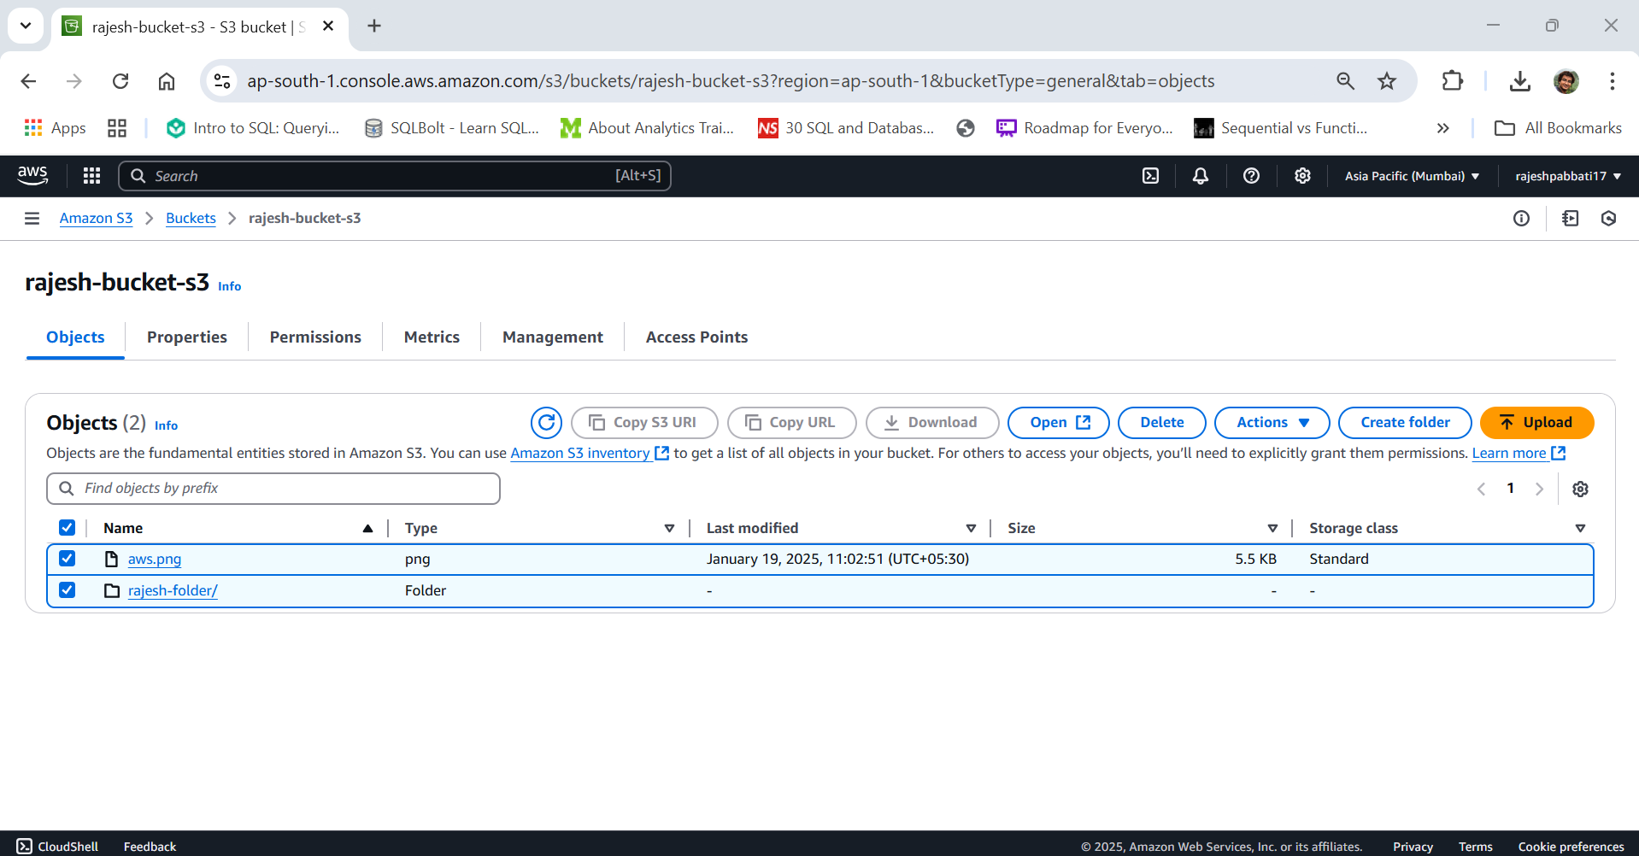

Confirm by typing permanently delete and click on Delete objects

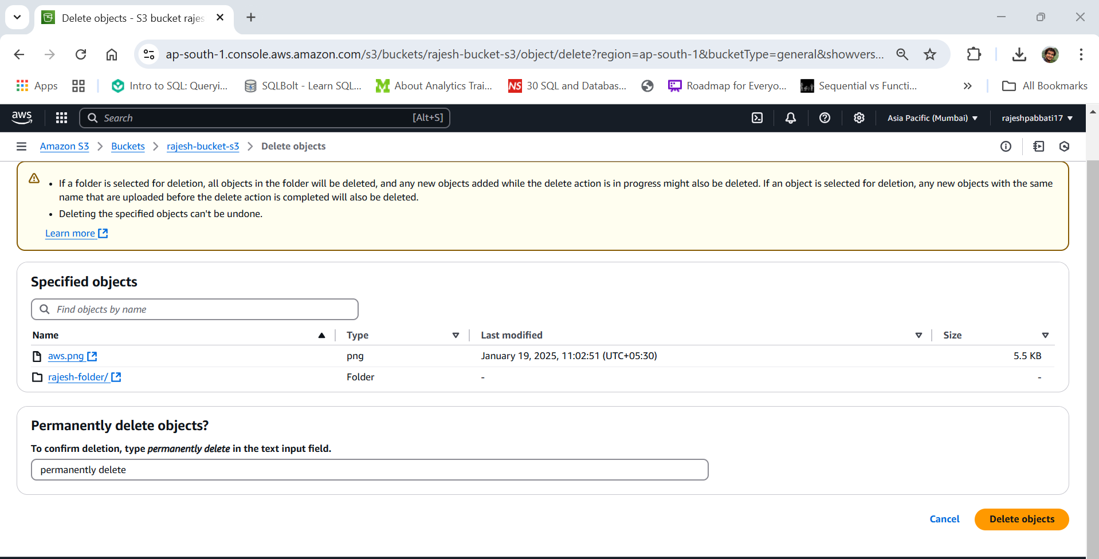

Navigate to bucket page select bucket and click on delete

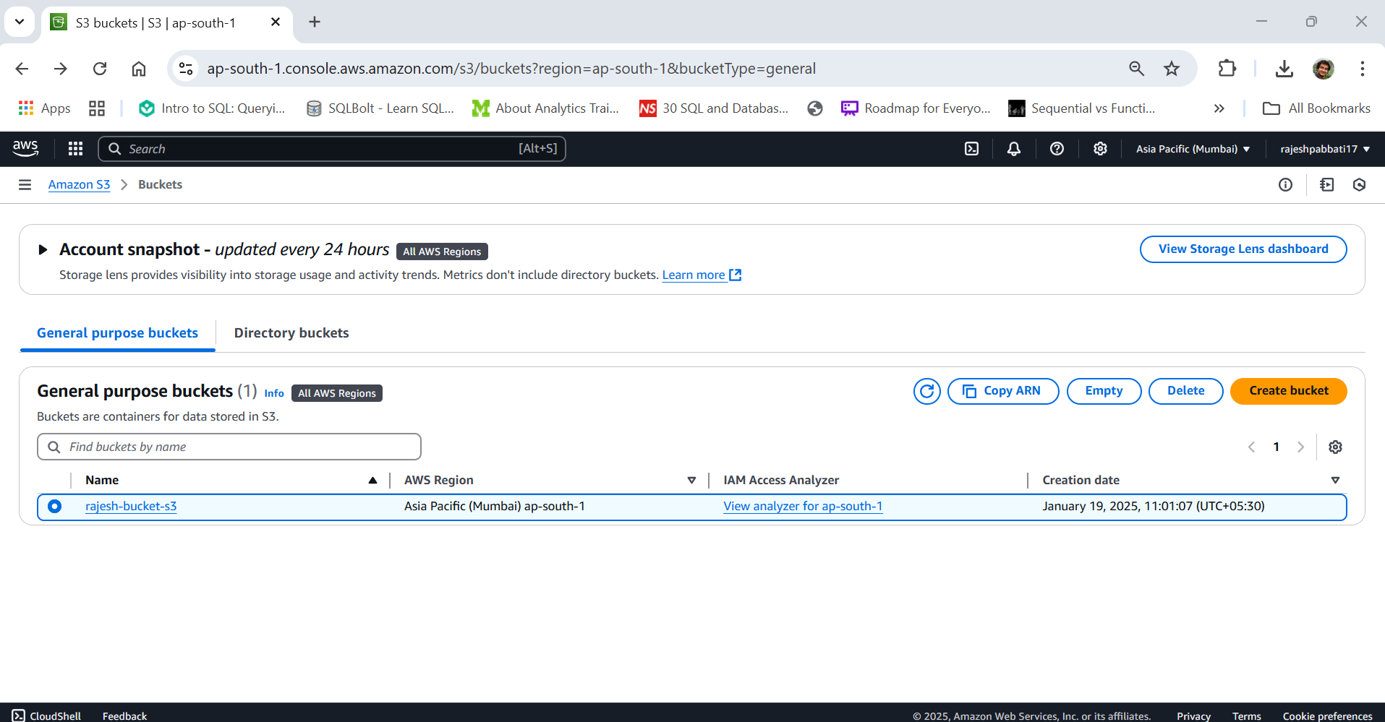

Confirm deletion by typing bucket and click on Delete bucket

